Matthew 25:31-46

This is an activity I used with Matthew 25:31-46. In this passage, Jesus begins
by talking about separating sheep and goats. The sheep are put on His right and the
goats are on His left. He talks to each group separately, telling them their eternal fate.
He tells the sheep that they helped him on earth and they wonder how. He tells them:
“I tell you the truth, whatever you did for one of the least of these brothers of mine,
you did for me.” He then tells the goats the opposite.

Cara always like cut and paste so this is an activity that she would enjoy.
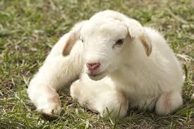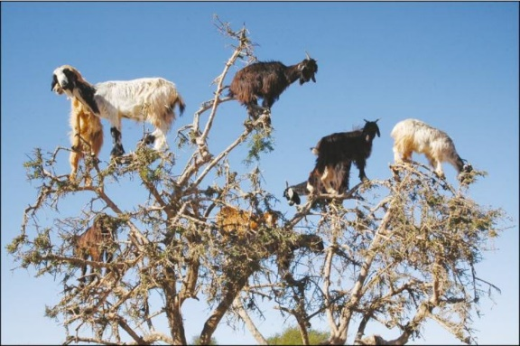

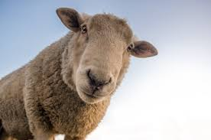

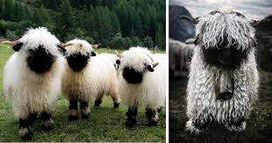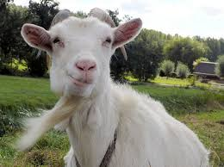

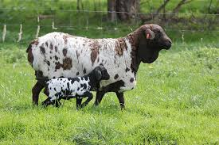

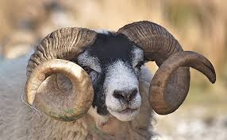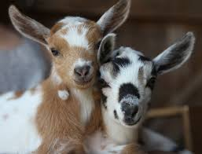

Sheep | Goats

