1 | 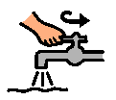  Turn on water | 7 | 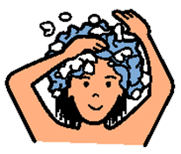  Put conditioner in hair | 13 | 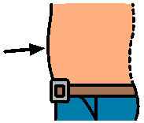  Wash stomach
2 | 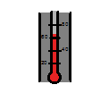  Check temperature | 8 | Wet washcloth | 14 | 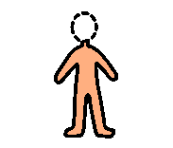  Wash left leg up and down 2X
3 | 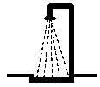  Turn on shower | 9 | Put on soap | 15 | Wash right leg up and down 2X
4 | 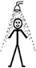  Wet body and hair | 10 | Wash face | 16 | Wash privates
5 | Shampoo hair | 11 | Wash left arm up and down 2X | 17 | Rinse hair and body
6 | 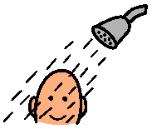  Rinse hair | 12 | Wash right arm up and down 2X | 18 | 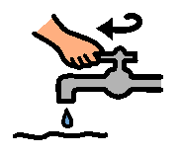  Turn off water

1 | Turn on water | 7 | Put conditioner in hair | 13 | Wash stomach
2 | Check temperature | 8 | Wet washcloth | 14 | Wash left leg up and down 2X
3 | Turn on shower | 9 | Put on soap | 15 | Wash right leg up and down 2X
4 | Wet body and hair | 10 | Wash face | 16 | Wash privates
5 | Shampoo hair | 11 | Wash left arm up and down 2X | 17 | Rinse hair and body
6 | Rinse hair | 12 | Wash right arm up and down 2X | 18 | Turn off water

