Doctors and nurses use tools to keep me healthy.

They use a scale to measure my weight. | 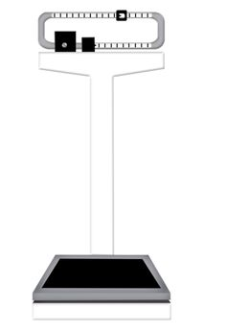
They measure my height.  I have to stand with my heels against the wall. | 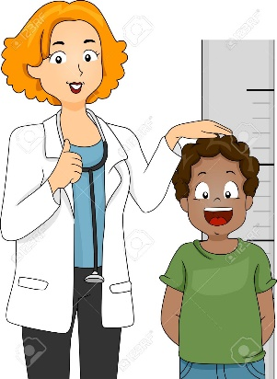
They measure my temperature with a thermometer. | 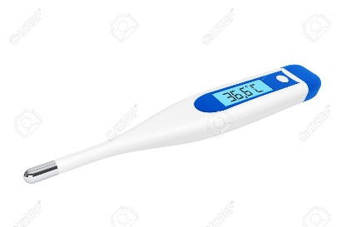
They measure my blood pressure. The blood pressure cuff hugs my arm. | 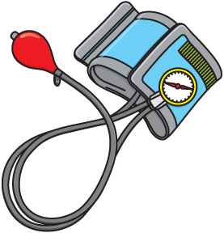
They use an otoscope with a light to look in my eyes, ears and mouth. | 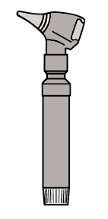
They use a stethoscope to listen to my heart. | 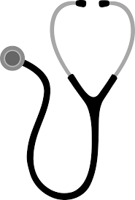
Sometimes they have to give me a shot. This is to keep me healthy. It will feel like a pinch, but it will be over fast. | 