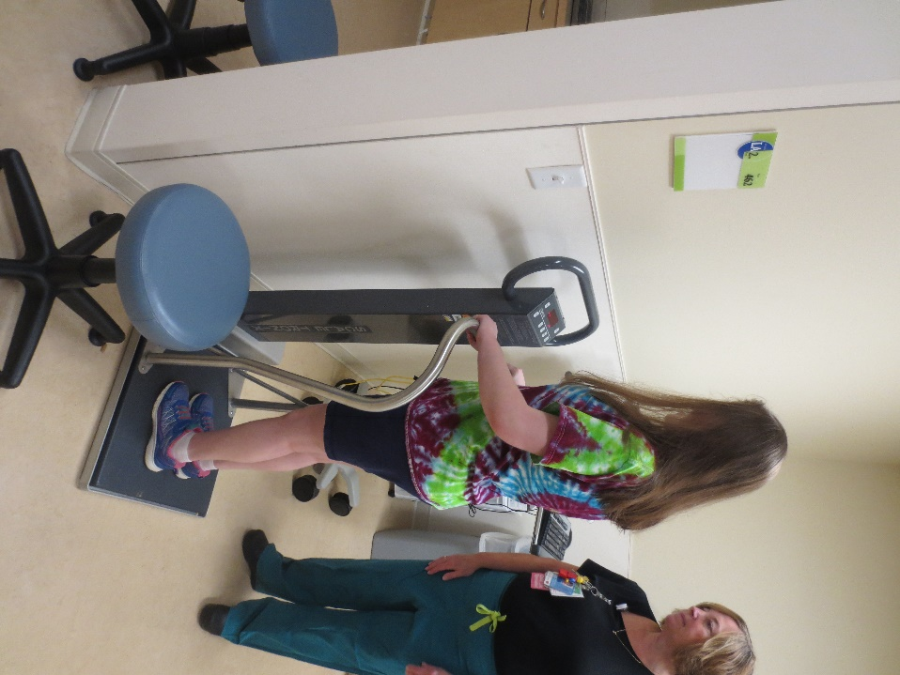

I will step on the scale and the nurse will use it to measure my weight.

**_____________________________________________________________________________________**

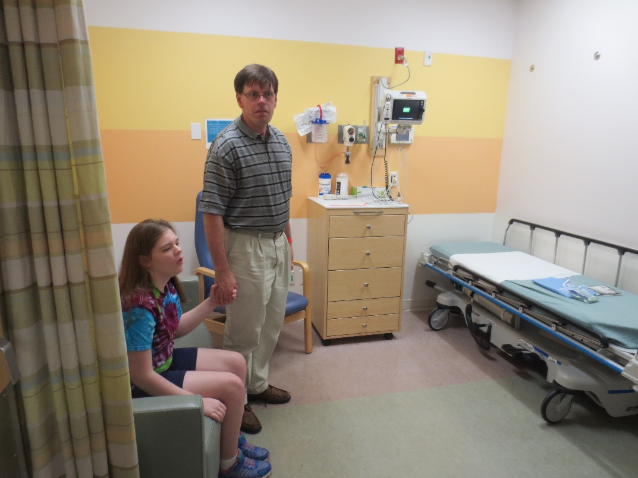

This is the room where I will have a checkup with a nurse. She will use different tools for the checkup.

I will lie down on the bed when I am asked to.

I am safe.

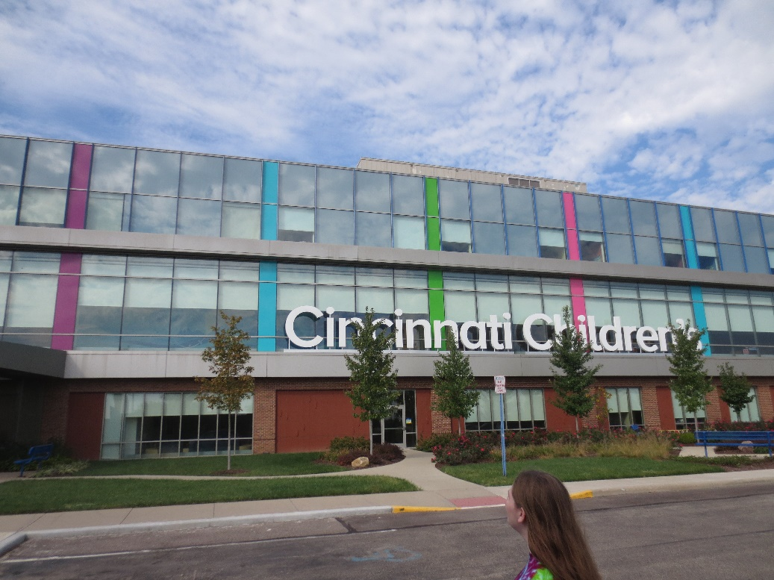

This is Children’s Hospital.

Doctors, dentists and nurses work here.

They will take good care of me and my teeth!

**­­­­­­­­­­­­­­­­­**

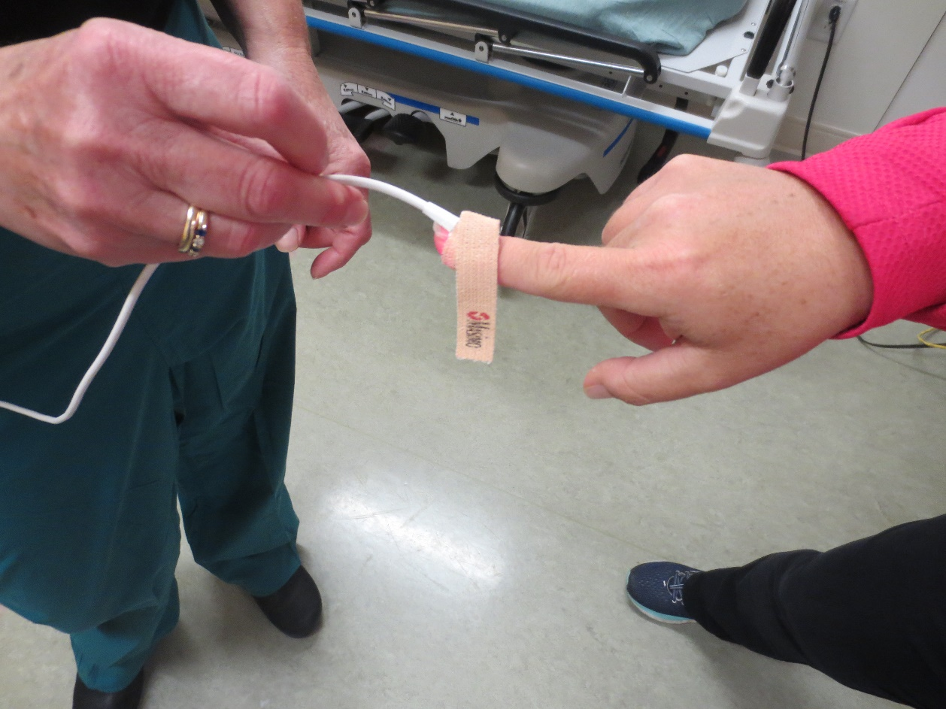

The nurse will wrap this around my finger. It is called an oximeter. It will not hurt me.

I am safe.

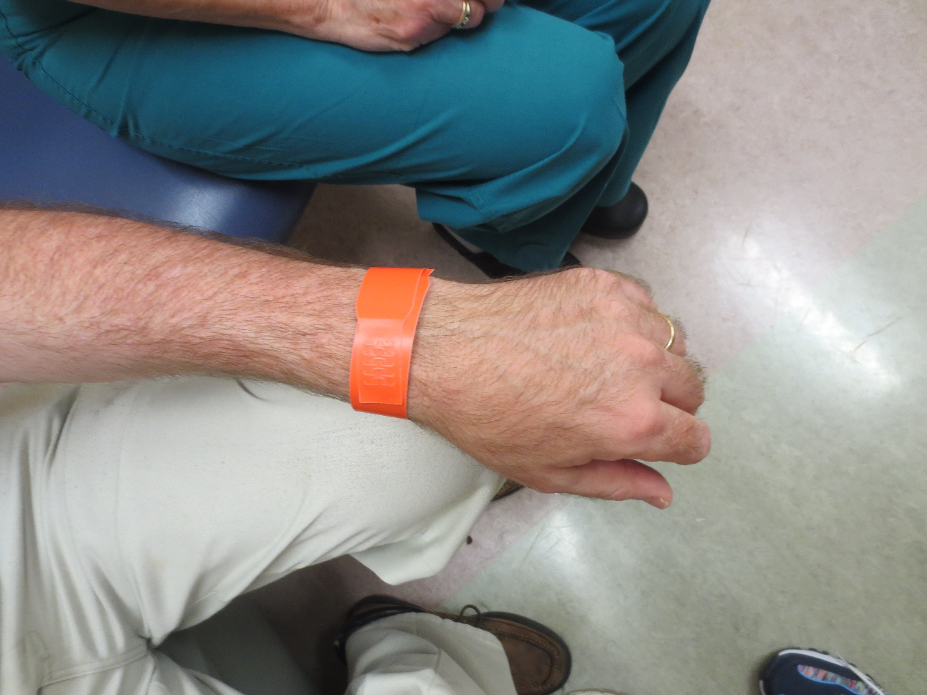

The nurse will put a bracelet on my wrist. This will have my name on it so people will know who I am. The bracelet will not hurt me.

I am safe.

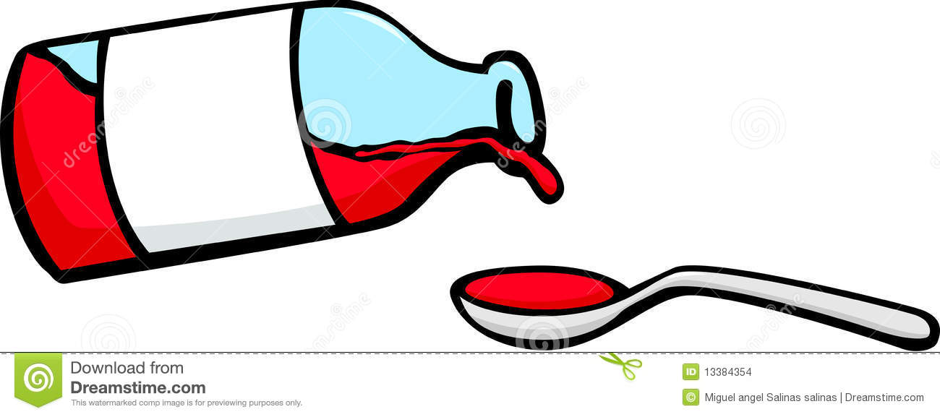

I will drink some medicine and it will make me sleepy. This is okay. I can lay down and take a nap.

I am safe.

**_____________________________________________________________________________________**

This is a mask that will be placed over my nose and mouth. I will breath in and the air will make me sleepy. It is okay to take a nap.

I am safe.

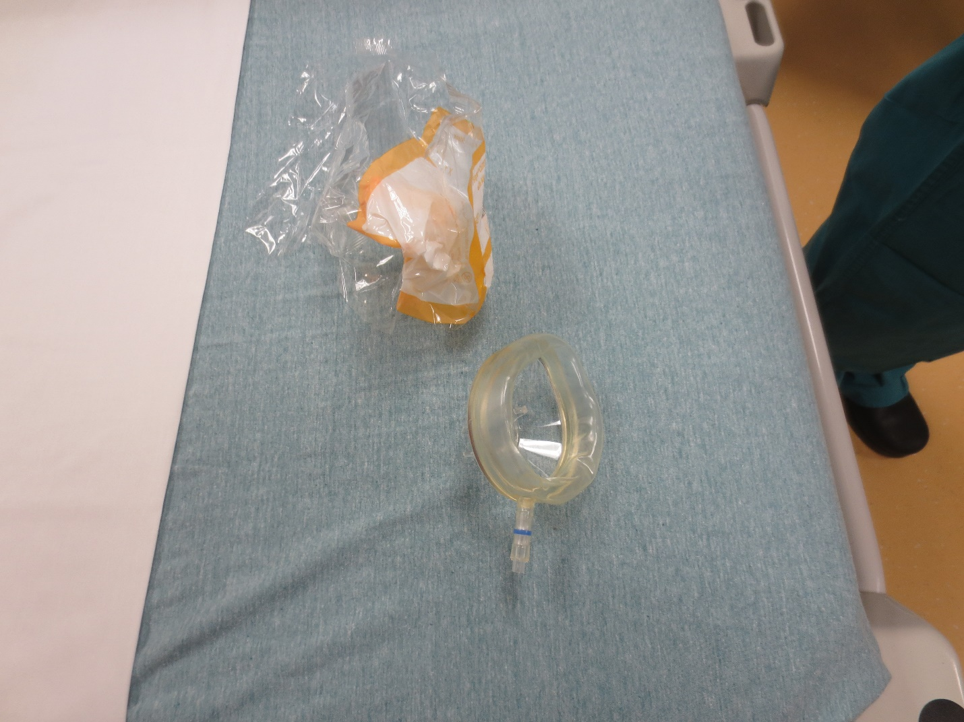

**_____________________________________________________________________________________**

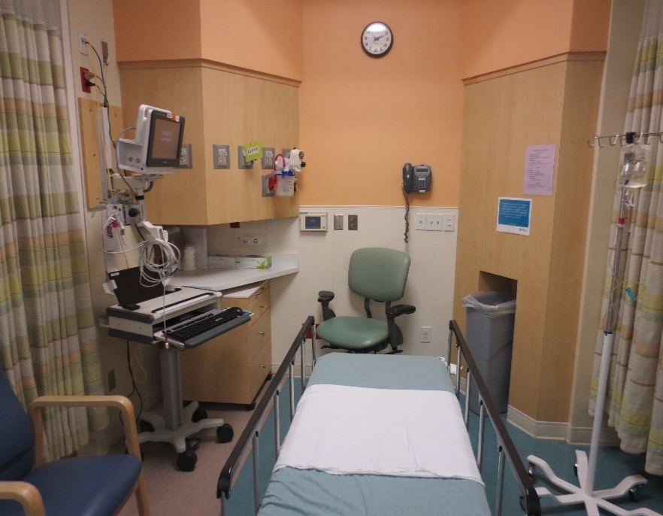

I will wake up in a room that looks like this. There will be a nurse to take good care of me. Mom and Dad will be there.

I am safe.

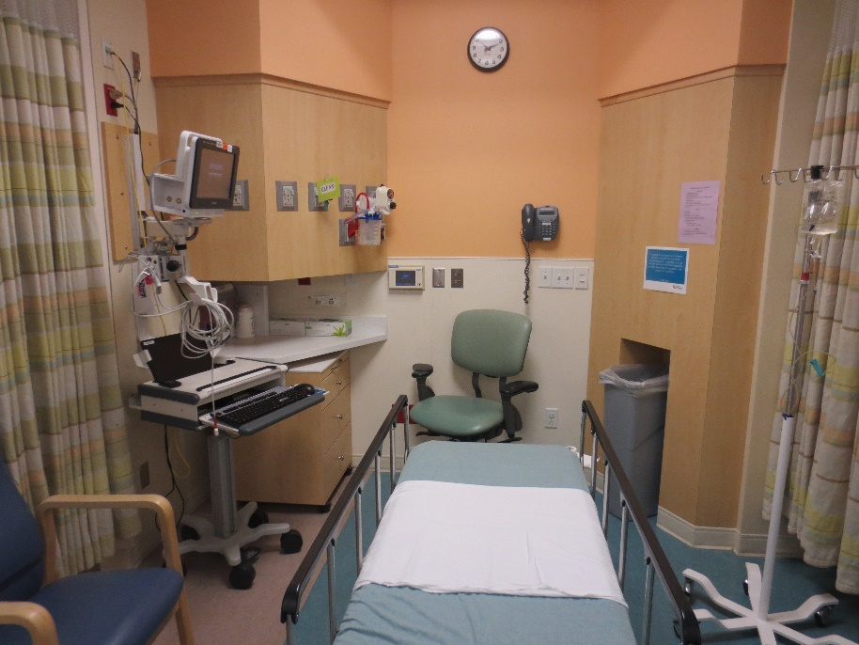

When I first wake up I will have a lot of bandage tape on my arm. The nurse will take this off right away.

I am safe.

**_____________________________________________________________________________________**

When it is time to go home, it might be hard for me to walk. I can sit in a wheelchair while someone pushes me to the van, and that is okay. Now I can go home.

I am safe.

