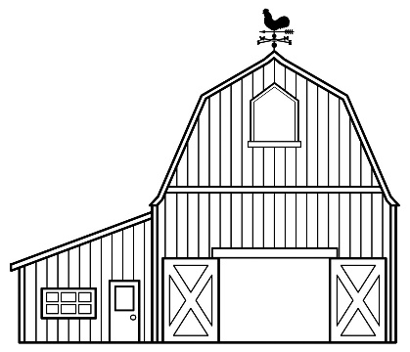 | 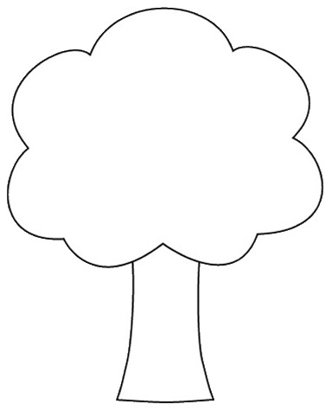  This Photo by Unknown Author is licensed under CC BY-NC
 | 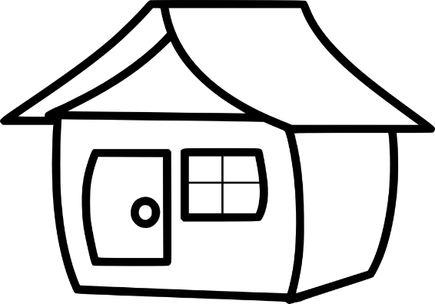

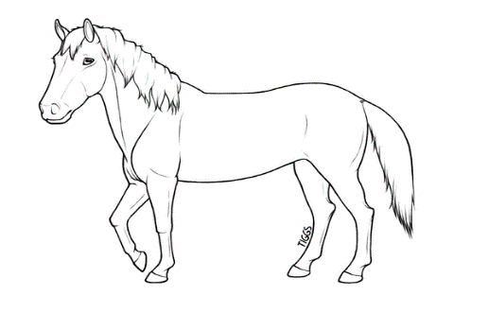 | 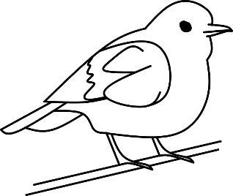
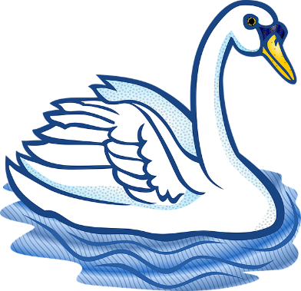 | 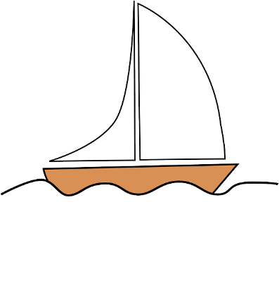
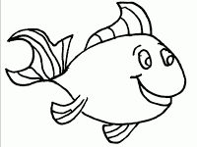 | 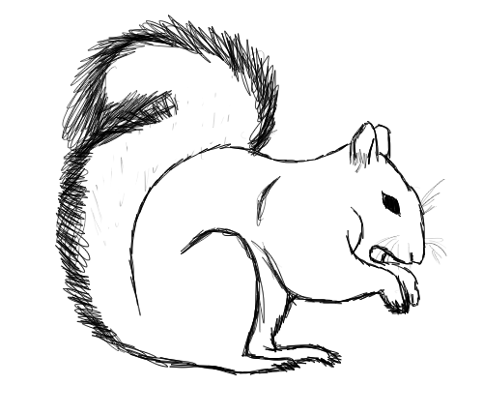  This Photo by Unknown Author is licensed under CC BY-NC-ND
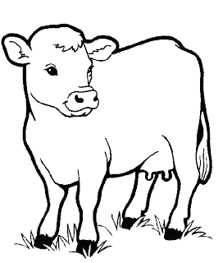
This Photo by Unknown Author is licensed under CC BY-SA-NC

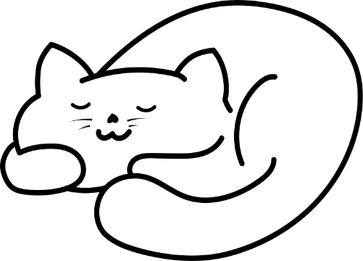  This Photo by Unknown Author is licensed under CC BY-SA | 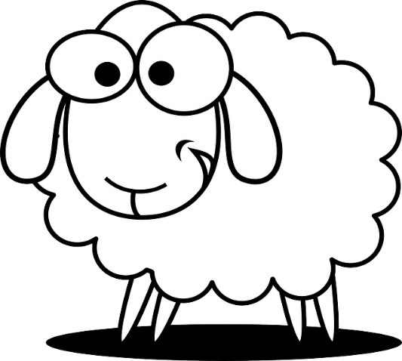

Directions

1. Color the barn red.

2. Color the top of the tree green and the bottom of the tree brown.

3. Color the lake blue.

4. Color the door of the house red, the roof of the house purple and the rest of the house grey.

5. Cut out the barn, tree, lake, and house.

6. Glue the barn on the pink envelope. Glue the tree on the blue envelope. Glue the lake on the yellow envelope. Glue the house on the green envelope.

7. Color the fins on the fish green.

8. Do not color the person.

9. Color the horse black.

10. Color the bird red.

11. Color the sailboat blue.

12. Do not color the swan.

13. Color the squirrel grey.

14. Color the cow brown.

15. Color the cat orange.

16. Do not color the sheep.

17. Cut out the items on pages 2 and 3 along the black lines. Place them in their correct envelopes.

