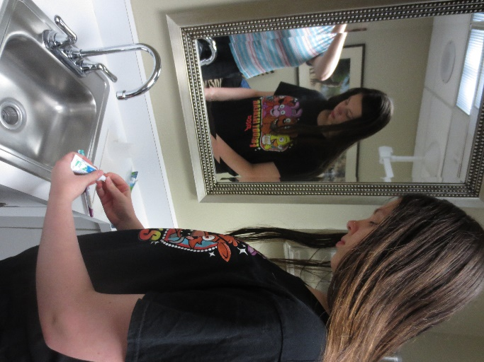 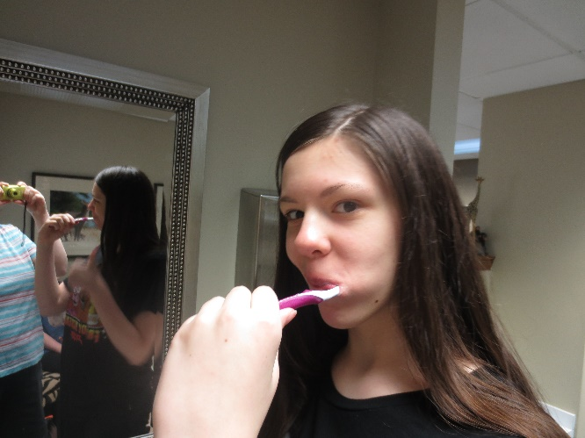

ADD PICTURE HERE

Taking care of my teeth is very important. __________is my dentist. I know __________ and he is nice. He helps me take care of my teeth.

First, I need to get my teeth clean. I put toothpaste on my toothbrush and brush my teeth.

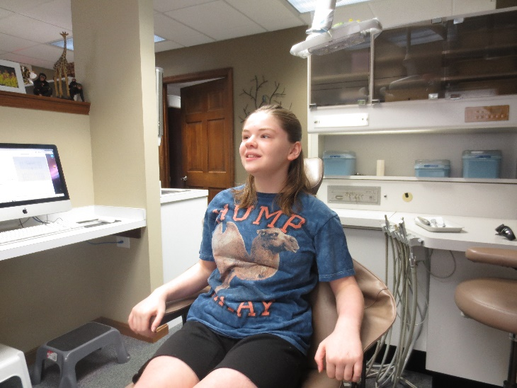 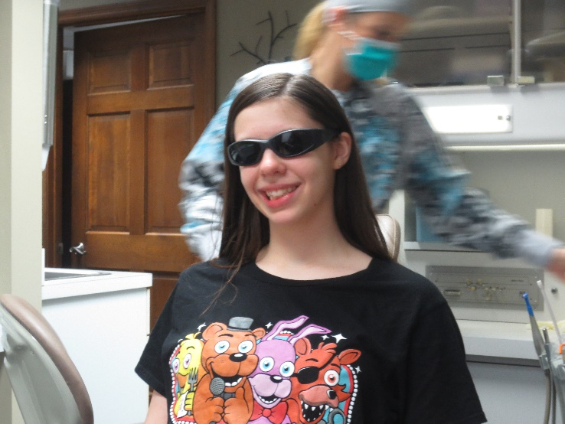

I sit in the chair.

I put on sunglasses.

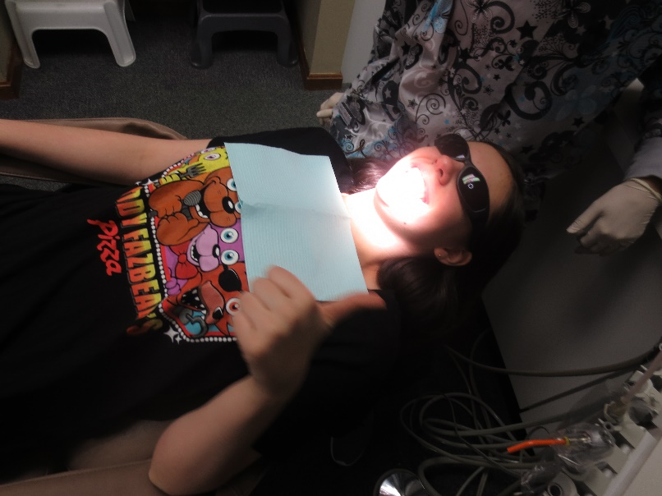 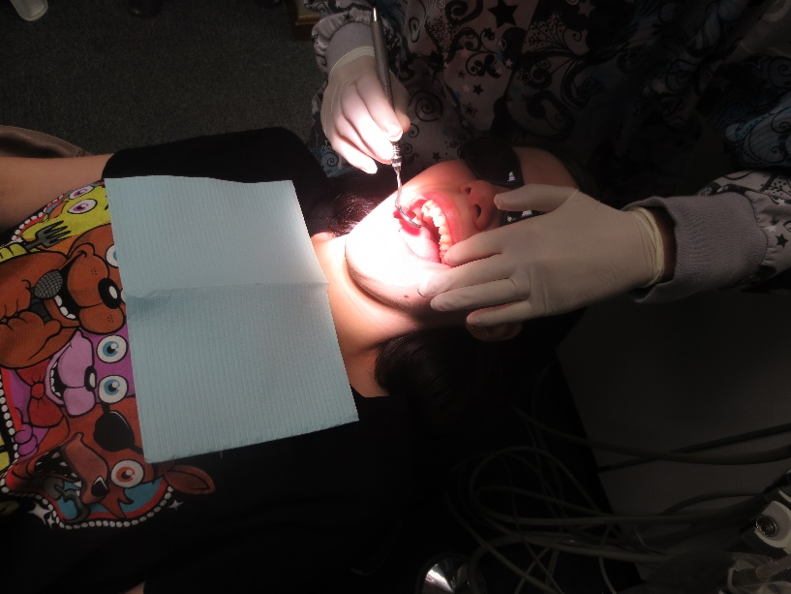

The chair will lean back.

The hygienist will use a mirror and count my teeth. If she has to, she will scrape off any bad stuff.

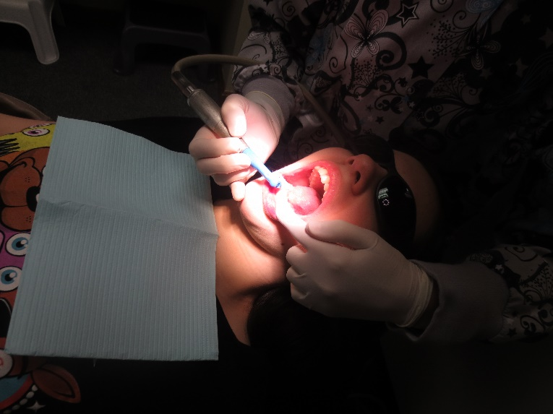 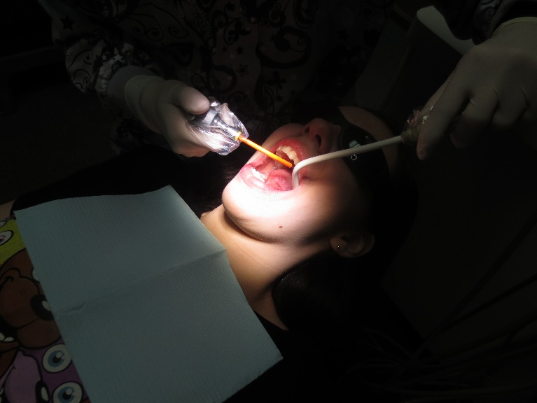

The hygienist will rinse out my mouth and clean the paste off of my teeth.

The hygienist will polish my teeth.

This will feel and sound like my electric toothbrush at home.

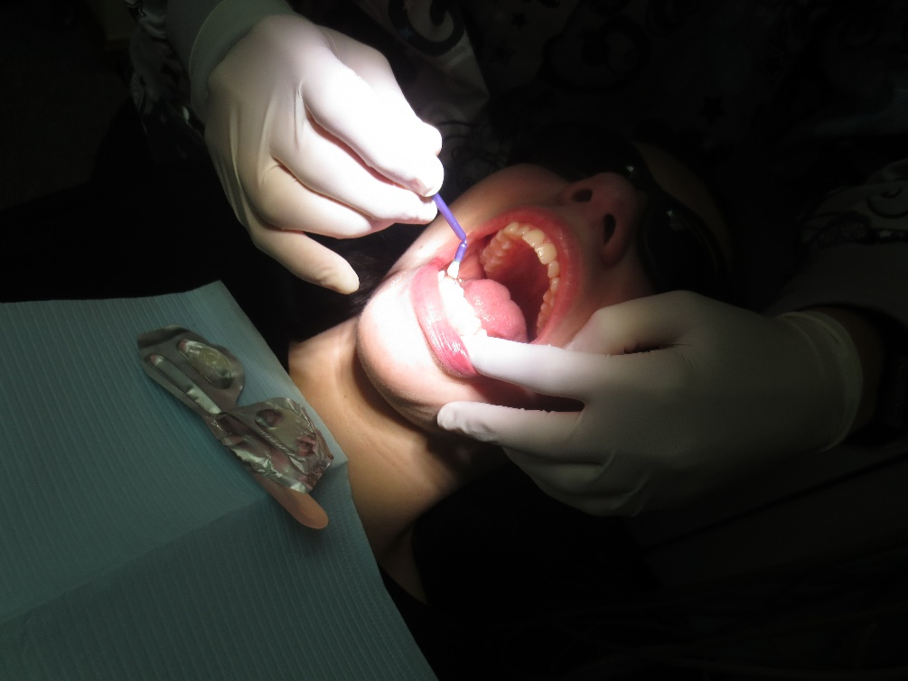

The hygienist will paint my teeth.

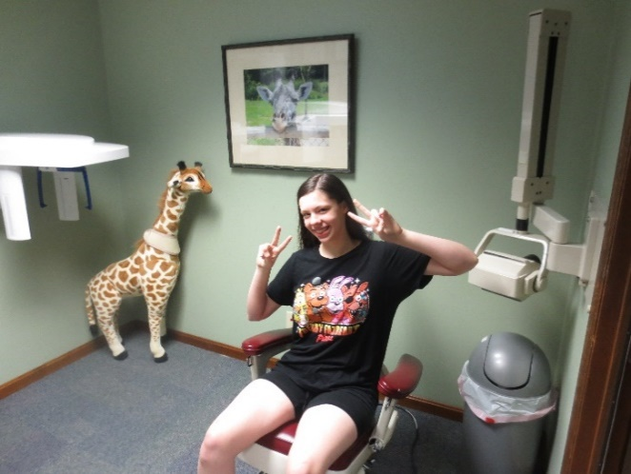

I will have special pictures taken of my teeth so I will go to a separate room.

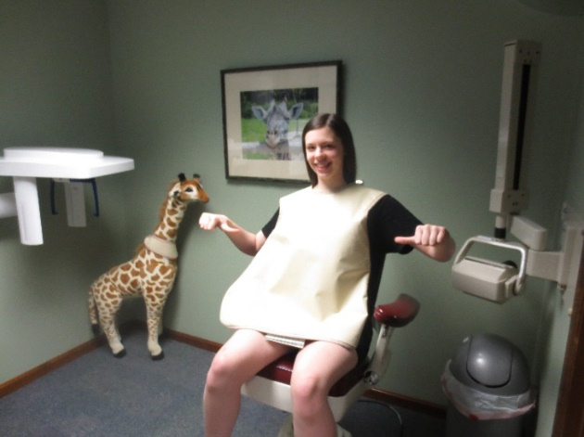

I will put on an apron.

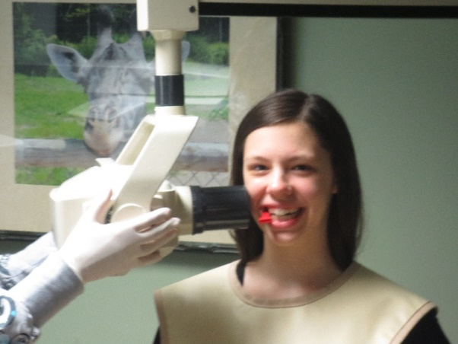

I will bite something between my front teeth and the machine will go around my head.

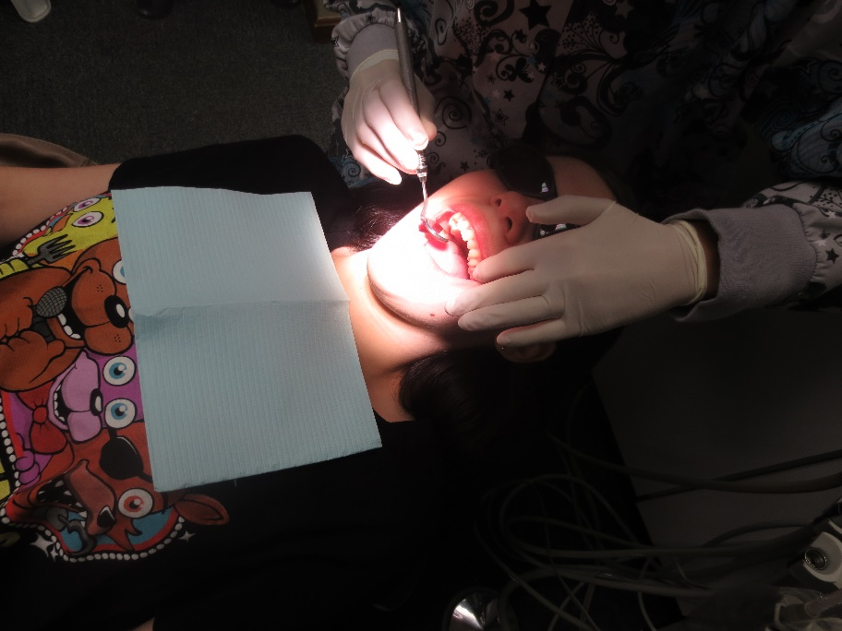

________ will come in and count my teeth.

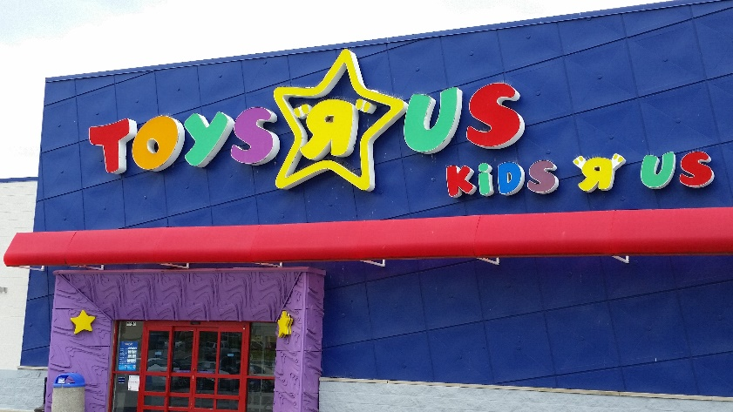

I am done at the dentist and now I get to go to Toys R Us.

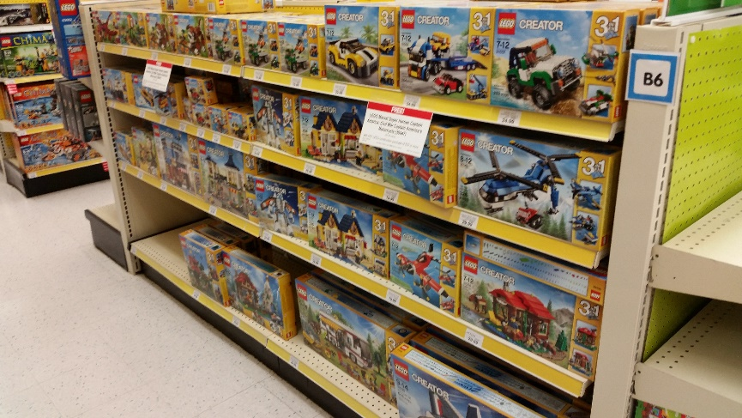

I will pick out some Legos to take home and play with.